Jenkins Setup:

1. Download Jenkins from https://jenkins.io/

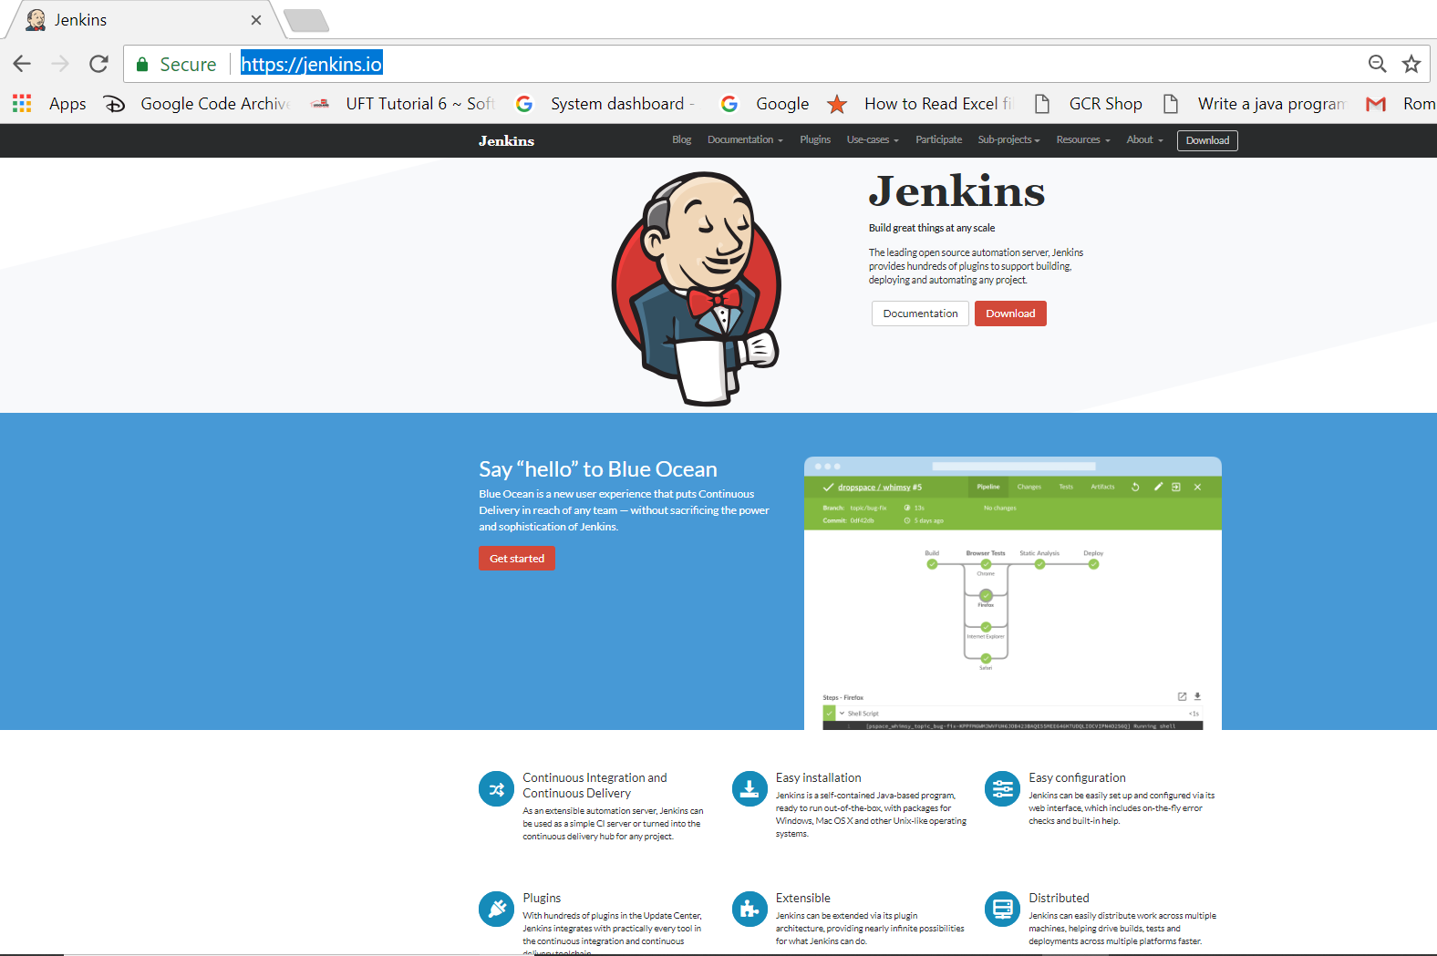

1. Select mac / window >>>>> start download
2. 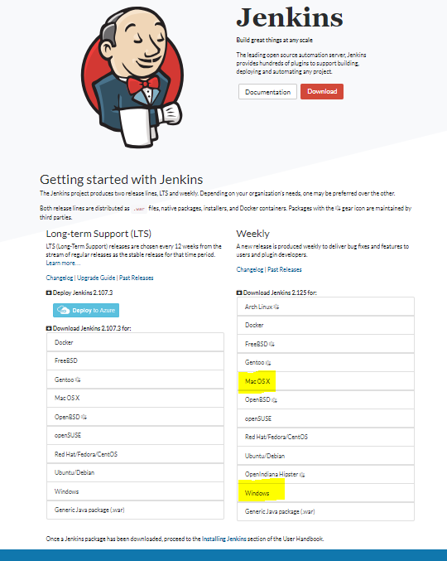
3. Go download folder and unzip file
4. 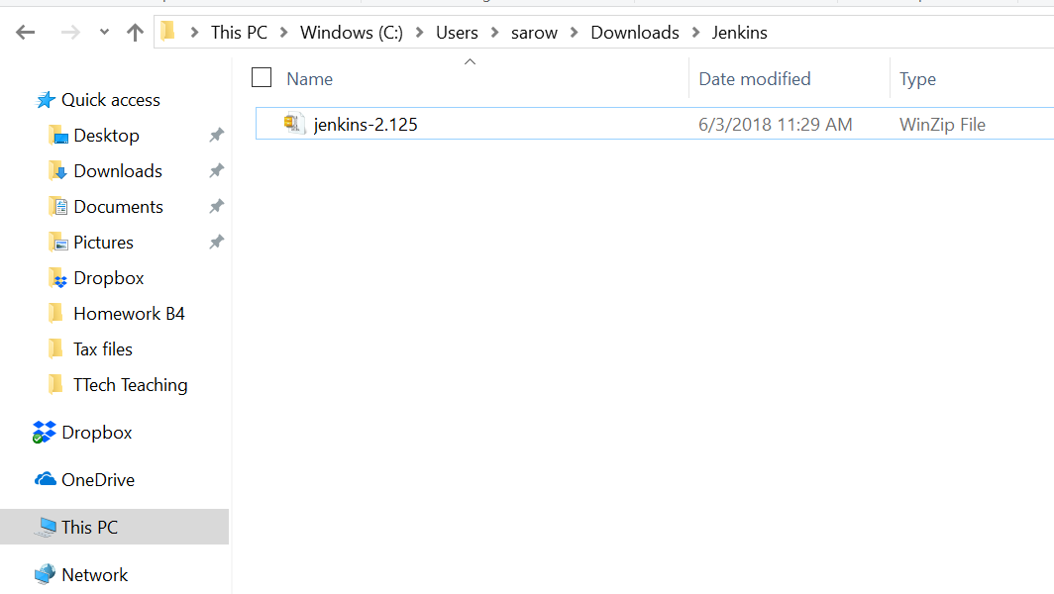
5. After unzip >>> click it
6. 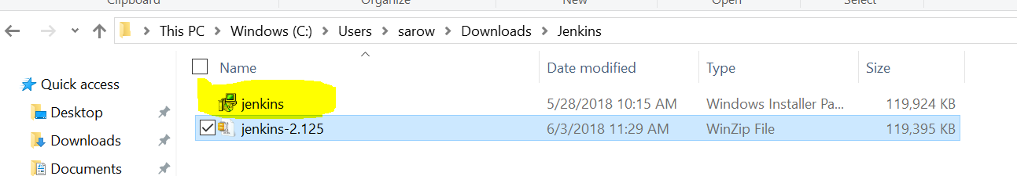
7. Clcik next

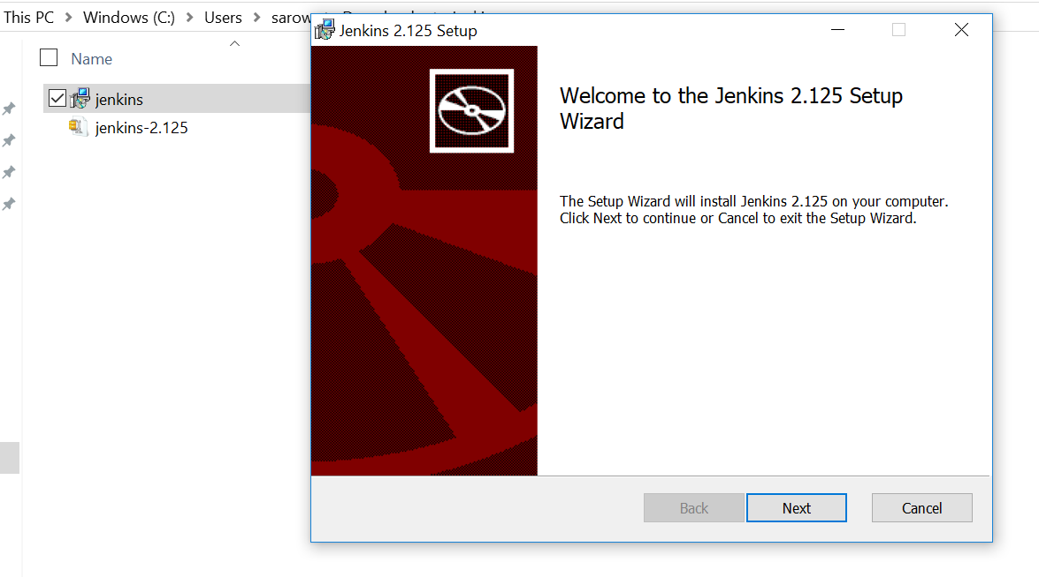

1. Check java : java –versions
2. If java installed in your machine than go next or install java
3. Install folder to C:\ Jenkins
4. Don’t install Jenkins to C:\Program Files(x86)\Jenkins – than you have ruby or cucumber problem as it’s an open bug for jenkins
5. Check Jenkins :: Open any browser and type this URL <http://localhost:8080/manage>
6. Open any browser and write and use your port number -default 8080 or any port like 9090

localhot/9090/manage or <http://localhost:8080/login?from=%2Fmanage>

1. Check admin password if you setup 1st Time
2. 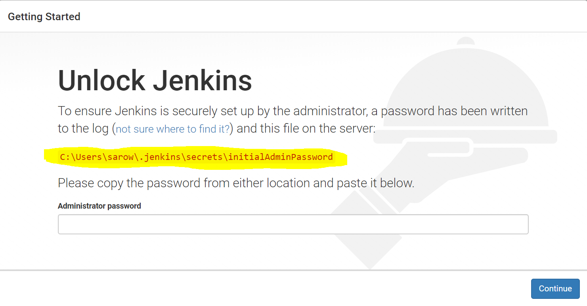
3. Open any folder and copy & paste yellow path
4. 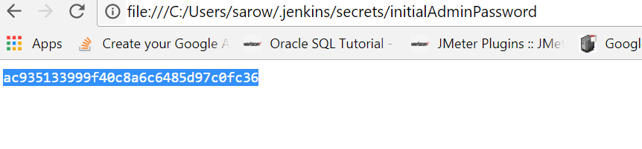
5. You will get admin password of your machine and copy it than paste it in Jenkins
6. 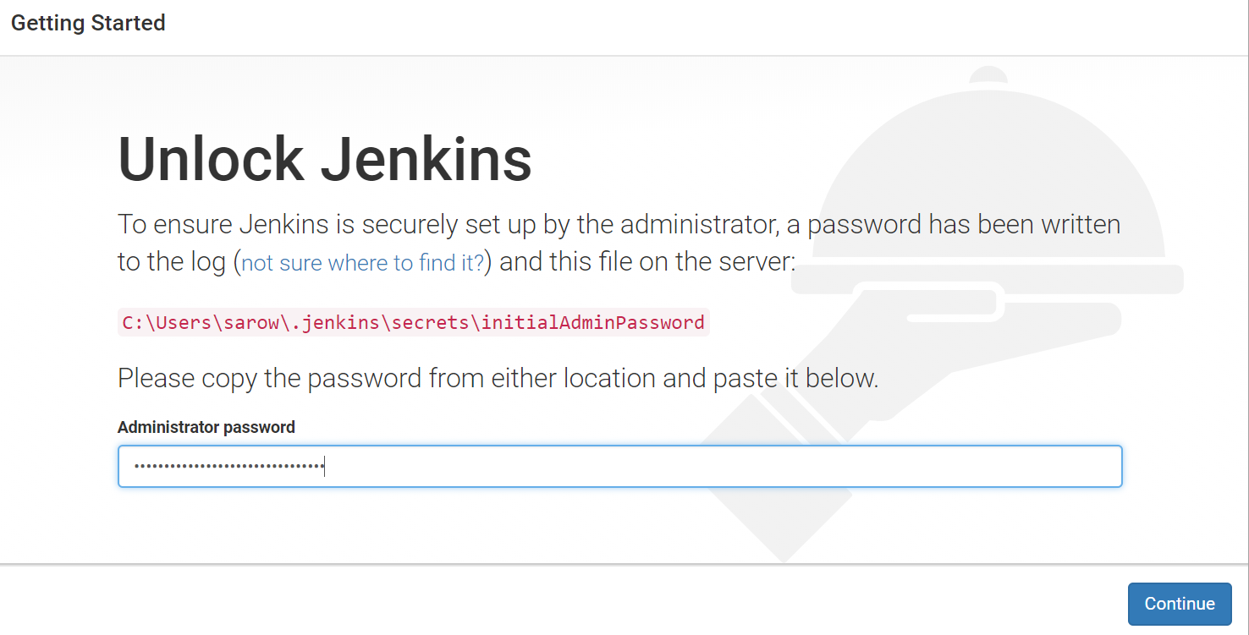
7. Click continue
8. Write <http://localhost:8080> or 9090(which port you mention in CMD)
9. 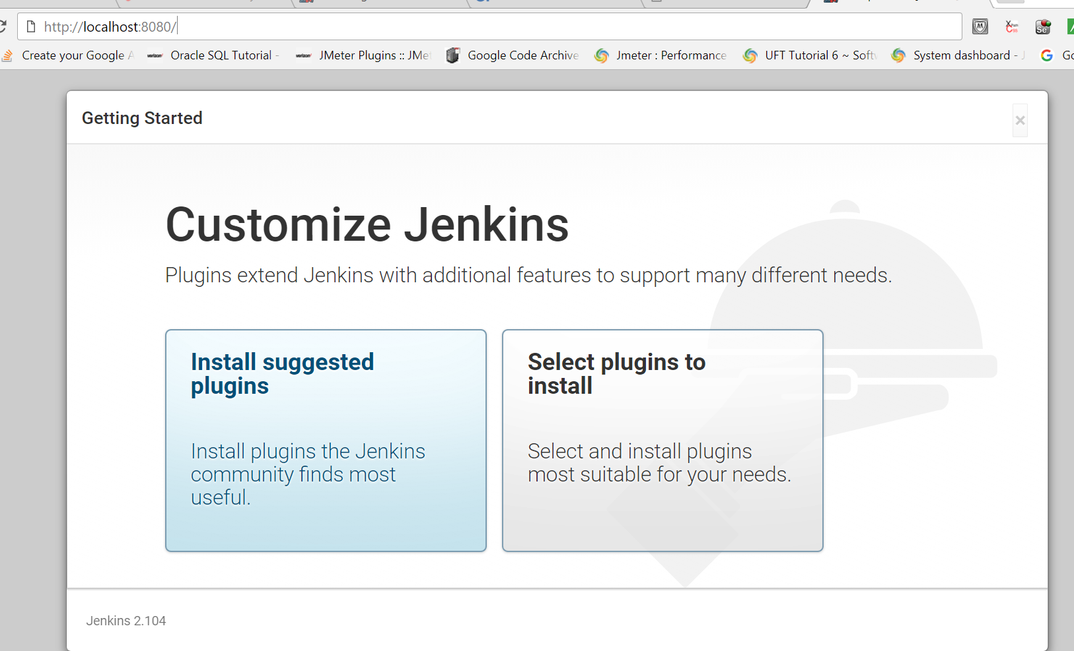
10. Click install suggested plugins
11. All necessary plugin will install
12. It will tell you to create account 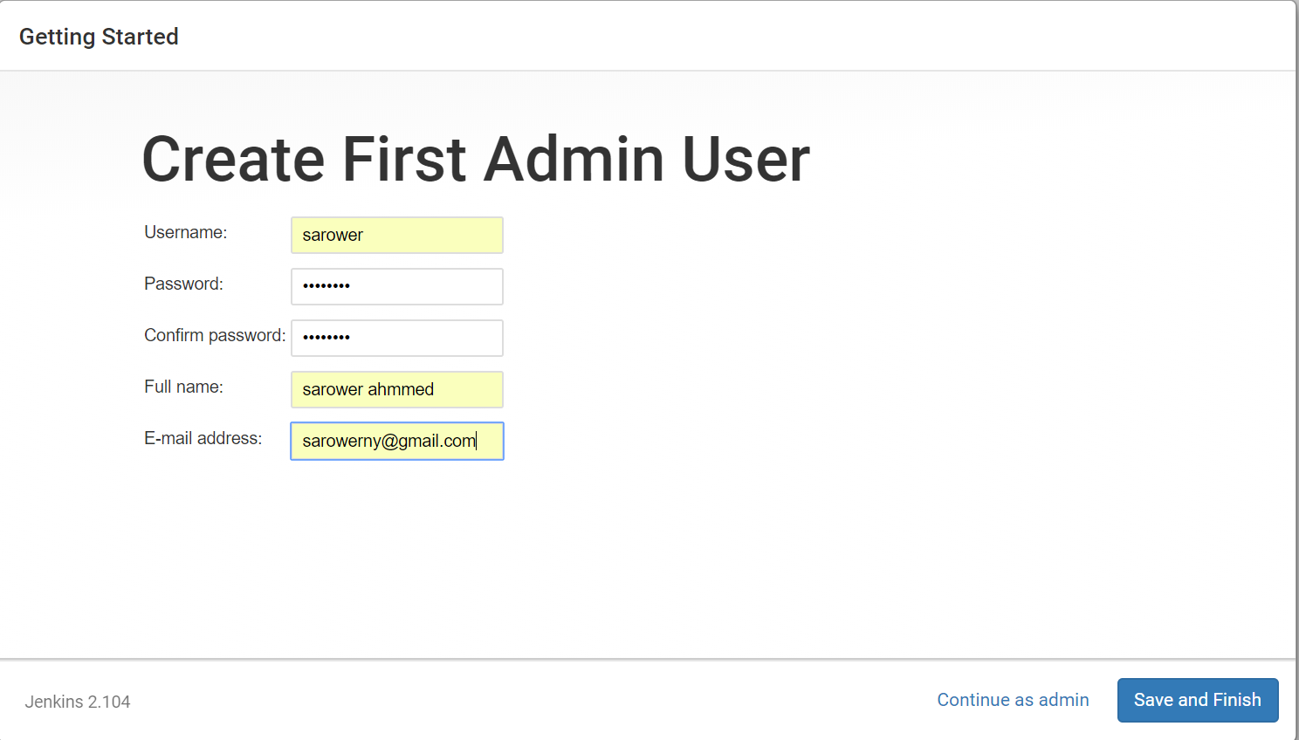
13. Click Save and Finish
14. 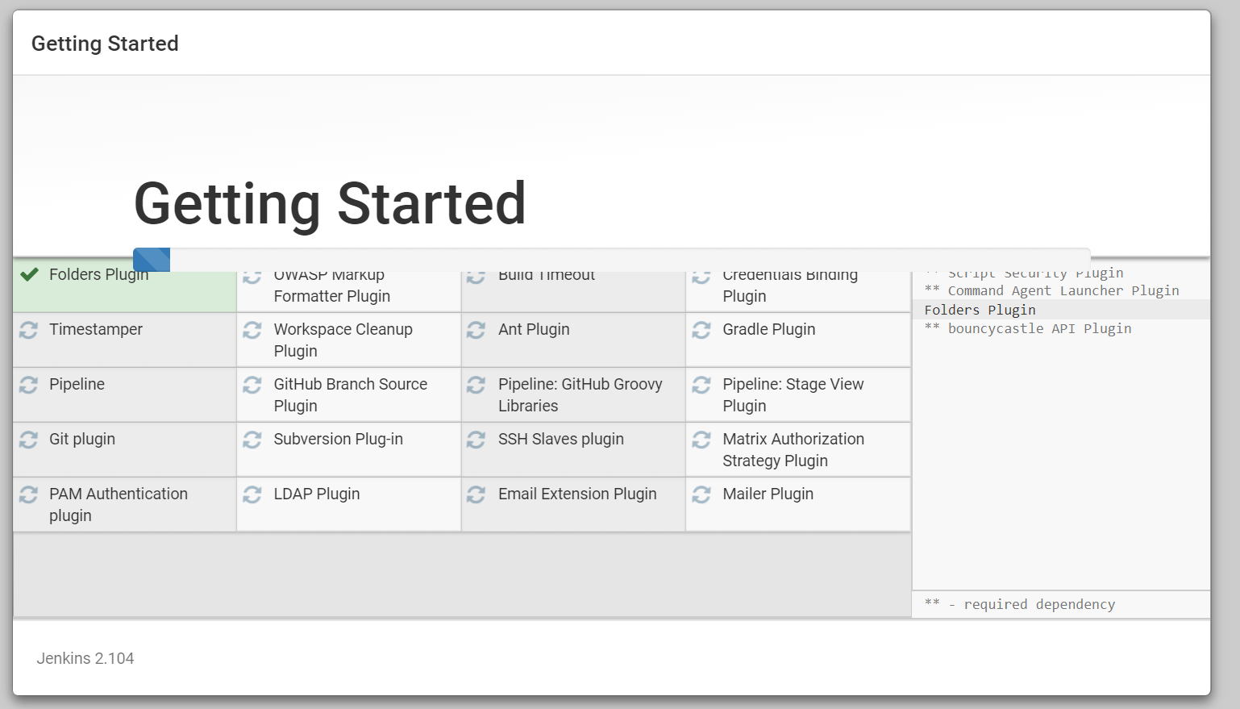
15. You can see Jenkins UI
16. 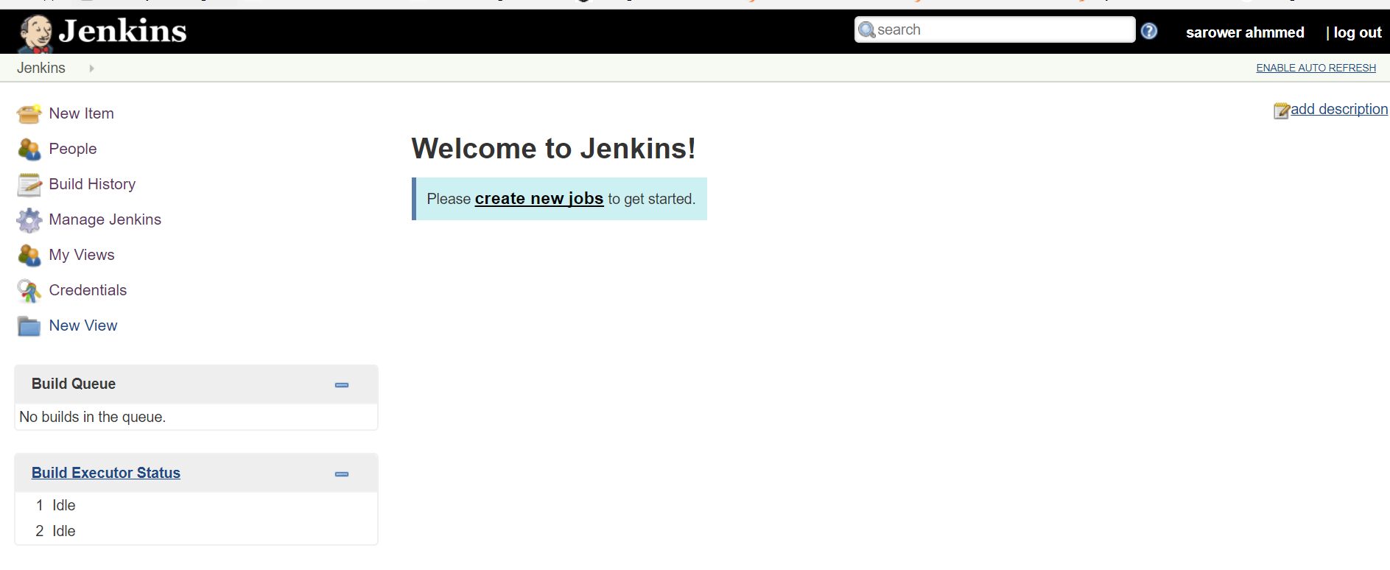
17. 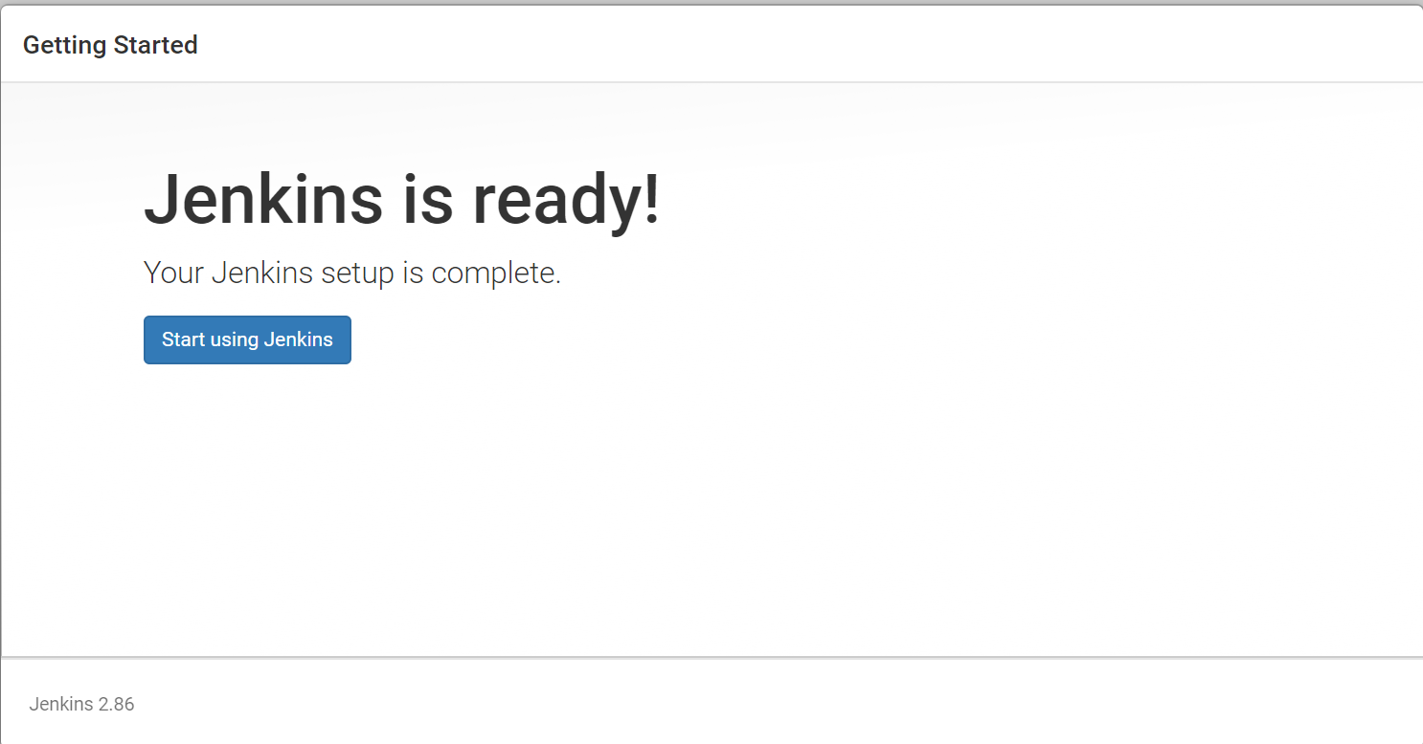
18. Now Jenkins UI ready to use
19. Click Manage Jenkins 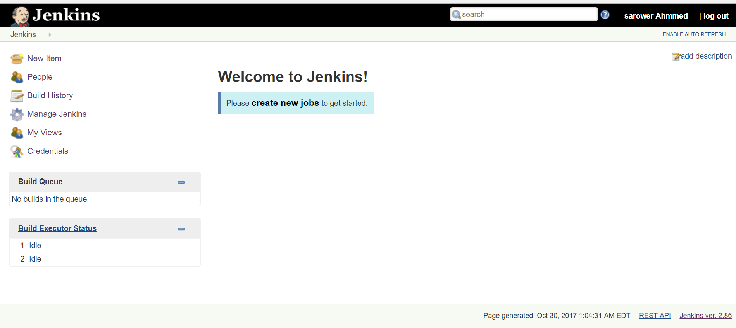
20. Click Global Tool Configuration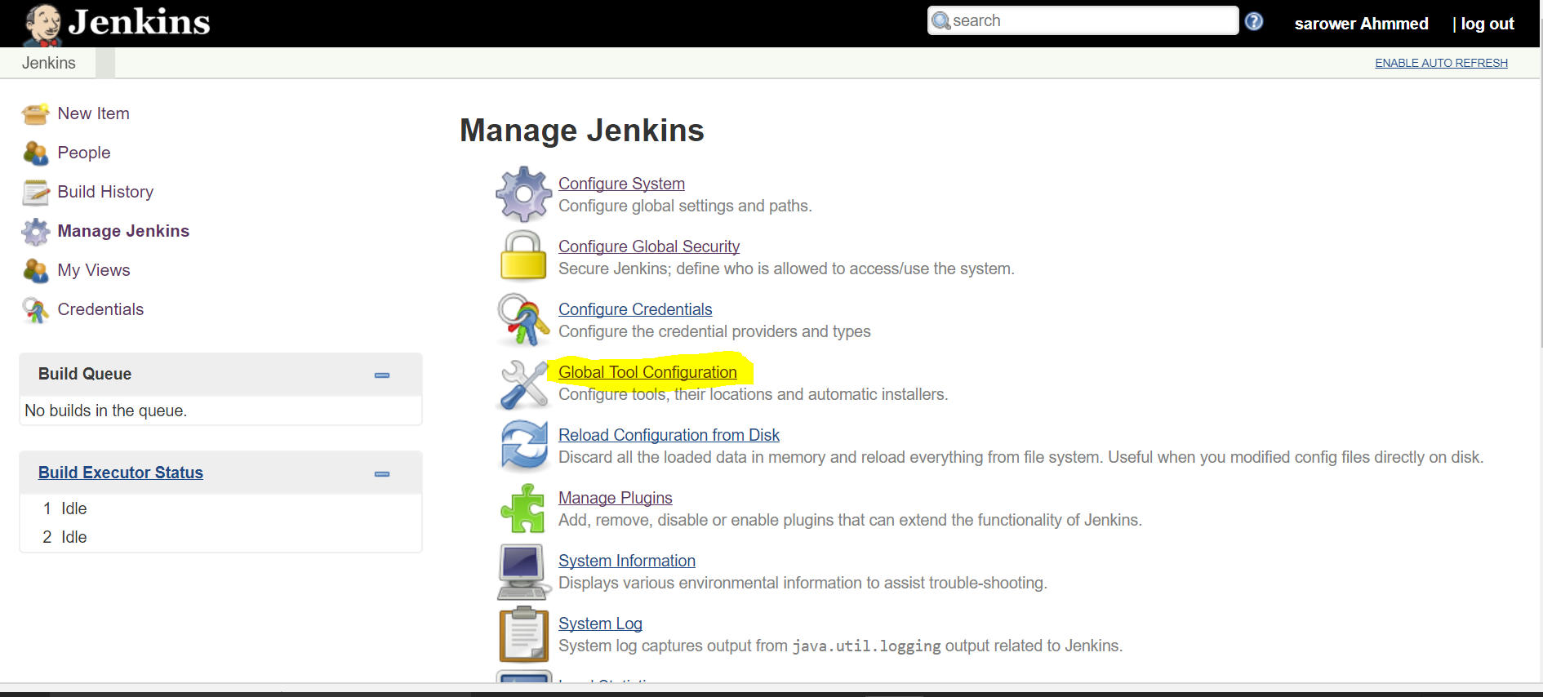
21. Click Add JDK 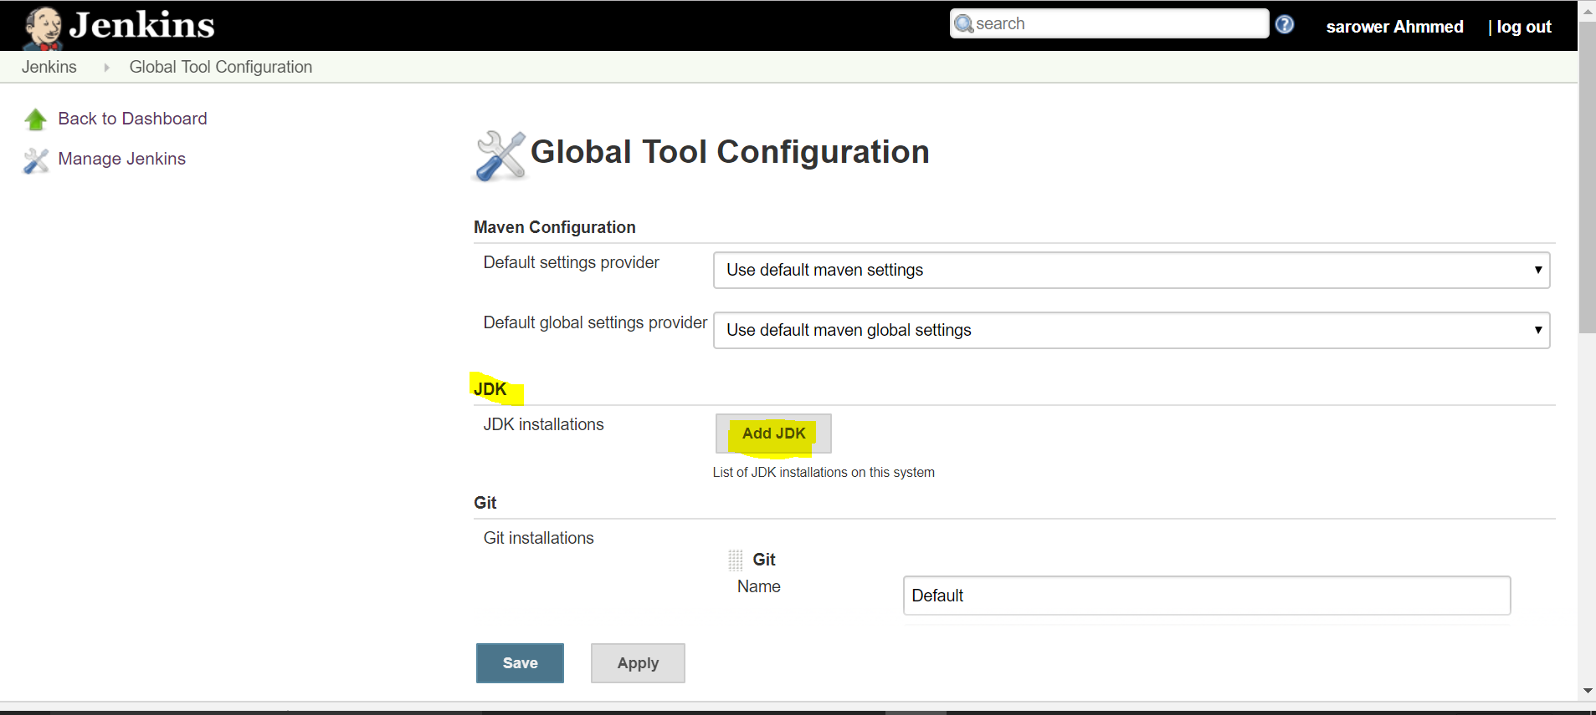
22. Name: JAVA_HOME and select JDK version. Check your JDK version and select your machine JDK version 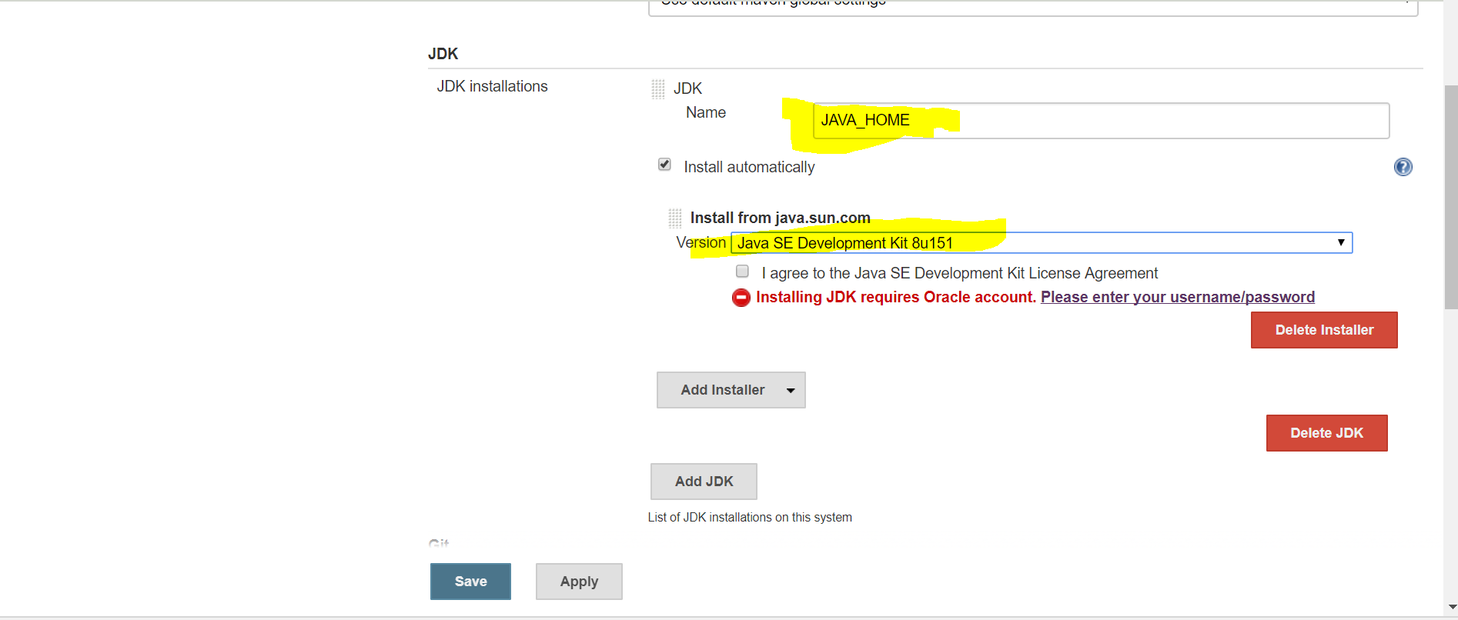
23. Click agree and save 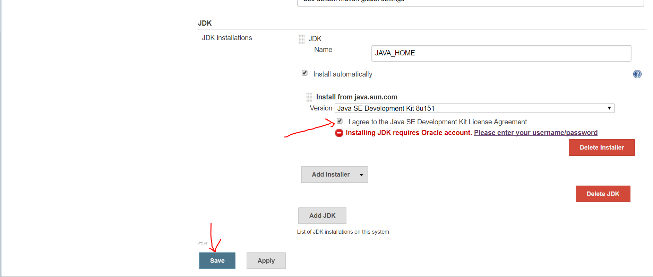
24. Click manage plugin again 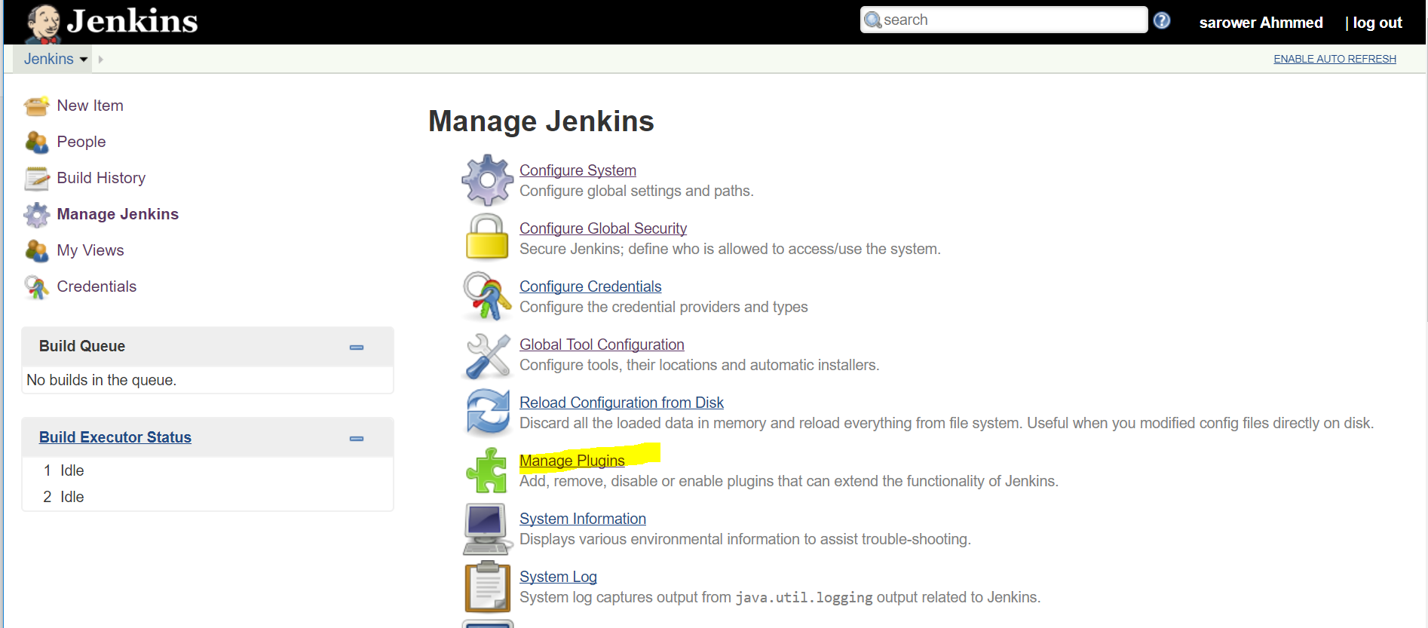
25. Click Available plugin> write GitHub in search box> check click GitHub Authentication plugins >install without restart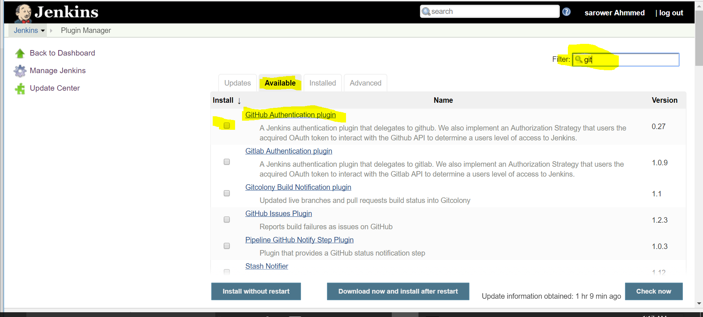
26. Go manage plugin> Available plugins> write Maven in search box> check click Maven Integration plugins> click check box > install without restart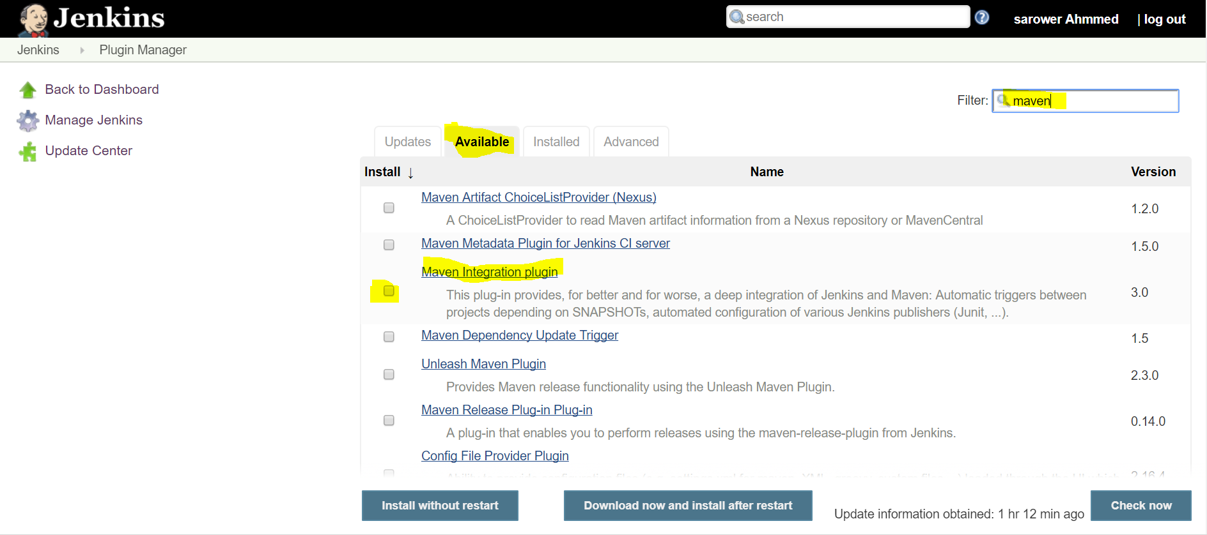
27. Go manage plugin> Available plugins> write Cucumber in search box> check click Cucumber reports , cucumber json test reporting ,cucumber trend reportsand cucumber plugins> click check box > install without restart (U can select all cucmber if u need slck or perf)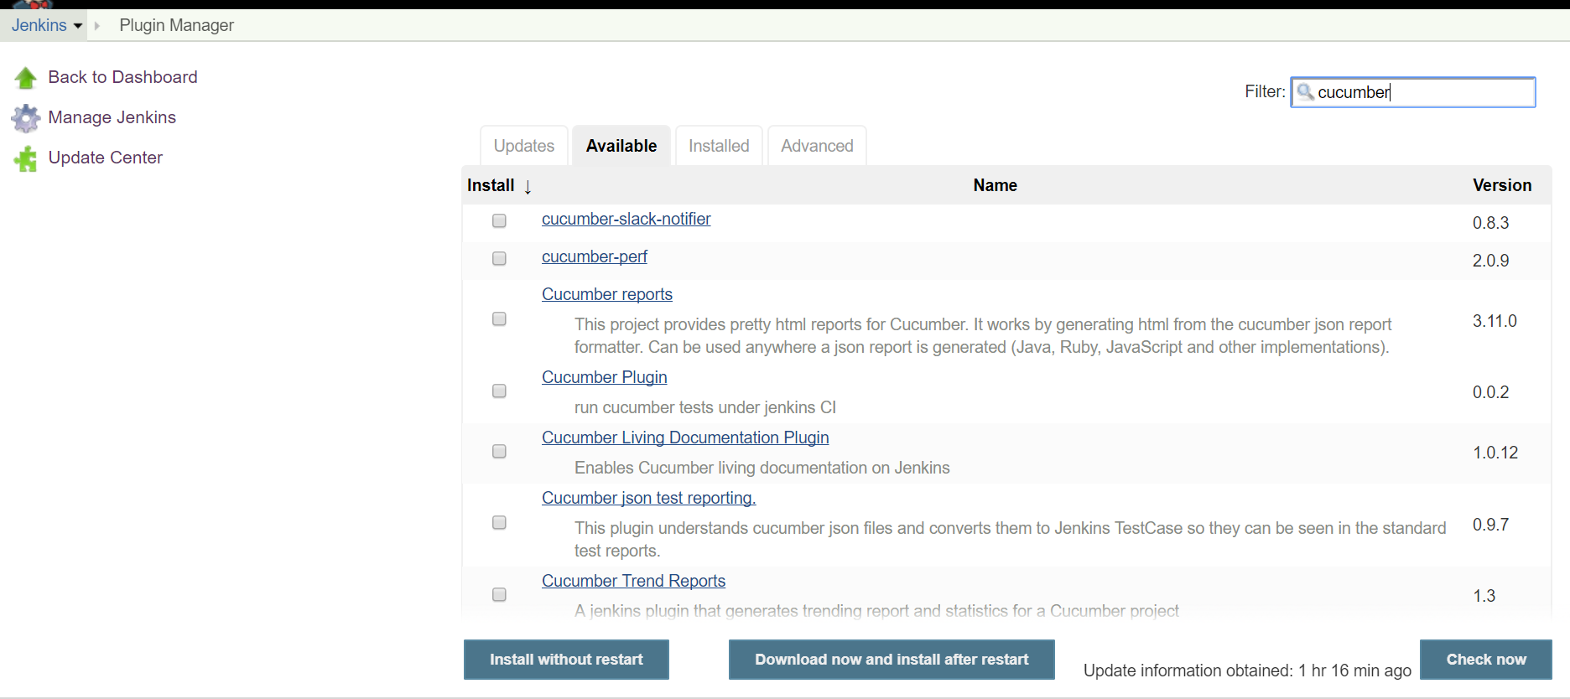
28. Click new Item 
29. Write project any name and select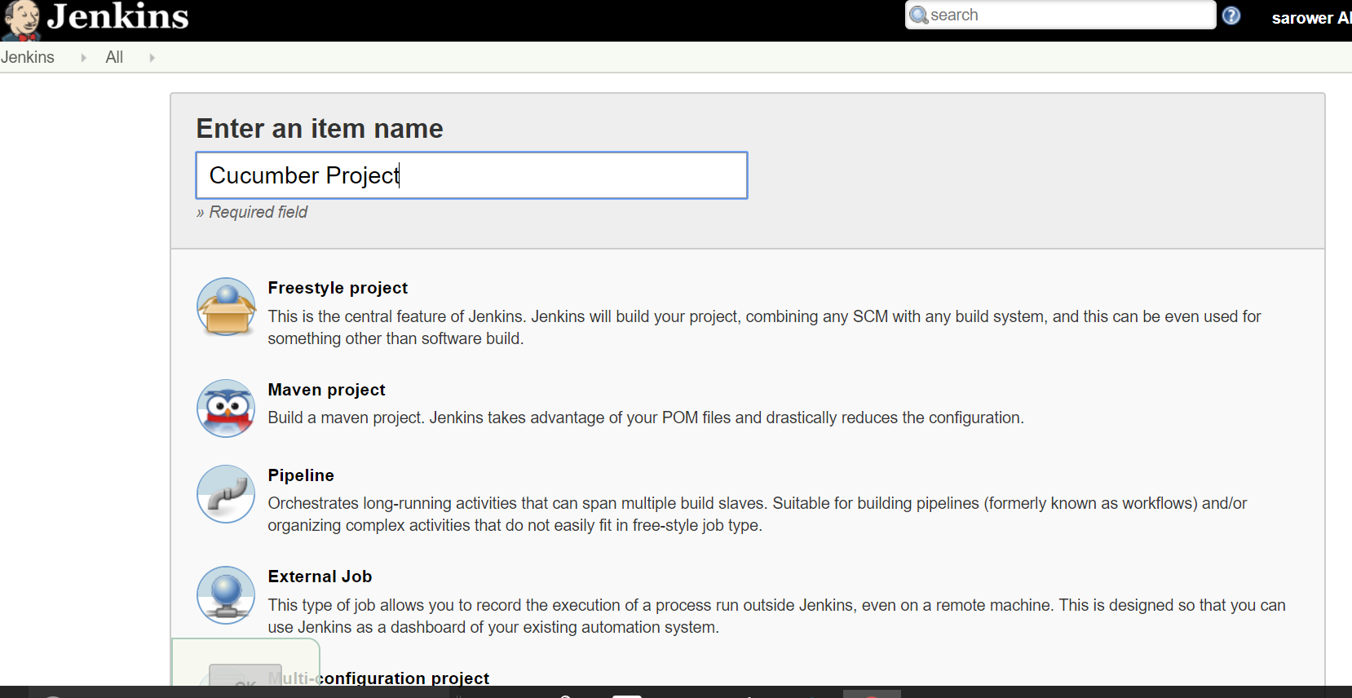
30. I will show you next part in class